## Project Research

1. What service(s) will the system provide?

Keeping Track of buses running, number of students traveling in a bus, rating drivers, payment through the app, information on route stops and timings, store information regarding transactions, buses running, and students traveling. Also saving transportation resources: calculating how many buses needed for each route and how many students will travel through each route so there’s no wasted resources.

2. Who are the main stakeholders and end users?

Stakeholders - The third party transportation company, AIU representative to the transportation company, AIU transport unit.

Third-party transportation company - The company is responsible for the physical transportation for Students, faculty members, and other AIU staff and as such is an important stakeholder in the process. They are expected to ensure that the goods are transported in a timely, efficient, and safe manner, and to provide regular updates to the AIU representative.

AIU representative to the transportation company - This person is responsible for communicating with the third-party transportation company. They act as a messenger between the transportation company and the AIU transport unit, and are responsible for ensuring that the process is done right.

AIU transport unit - This unit is responsible for overseeing the entire transportation process. They are expected to ensure the quality of service, and provide feedback to the AIU representative if there are any issues. They are also responsible for ensuring that payment is made to the third-party transportation company for the services provided.

End users - Bus drivers, students traveling to and from the university, AIU transport unit to keep track of financials and student registration.

3. How are you going to find users to communicate with throughout the design and development of the project?

Send out a mass survey asking users for features they would like to see and work on small releases implementing those features one by one and giving users access to the website and select users who filled out the form will be able to test out the app on their mobile device.

4. Who are the potential users that you have access to? (These will provide user stories, and will share feedback throughout the development process).

Students, faculty members, and other AIU staff traveling from Alexandria, Cairo, and other locations to and from the university

Those who travel daily to and from the university get updates on the location of the bus every morning through the whatsapp group or by calling the driver every few minutes. The bus makes its stops to take students along the designated route (sometimes it waits for an unestimated long time at the stops), then reaches the destination (the university), And at the end of the day everyone gets on their bus and leaves.

5. What communities is the system going to serve? What demographics? What locations?

Student population (17-23 years age), faculty members, AIU administrative and other staff (26-65 years age) mainly hailing from Alexandria, Cairo, Mansoura, Behira and Damanhour, etc.

6. How are you going to solicit user input in the initial phases of analysis and design?

Get extensive feedback from users through a dedicated form on the website and the app responsible for collecting data across different factors including ease, speed, user-friendliness, and effectiveness of the application.

7. What is "new" about the system? Is it the idea of it, or is it the way it approaches a solution that already exists?

Bridging a gap between users and the drivers/administrators to build a seamless system of creating and managing bookings. The users will be able to track the buses, see information on different bus stops, link their payment

method to the app, rate the drivers and administrators/drivers will be able to get useful data on the trends about the transportation system, understand user behavior on how to improve the system,and create a reliable channel to operate on.

1. What are the other systems that have goals similar to your system (mention some examples)? What criticism do you have about them? How do you think your system will be different?  
   Blacksburg Transit - The information about the stops is usually incorrect with the app taking forever to load and no support if there are any issues with the app. The app’s map view is not user friendly and new users have a hard time figuring out how to navigate through the app.  
   Salek - Signing up is a difficult process, the application is laggy, there’s no clear way on how to purchase packages.  
   Sobek Transit - Will use satellite view to give more accurate information on the bus routes and the map will update every 10 seconds to provide the latest information about the whereabouts of the bus. Users will have the ability to get notifications for certain routes and will be alerted when the bus is 10 minutes away. The app will maintain a history of the users last 5 trips to get assistance with and re-book the same trip efficiently. The app will be user friendly and will instruct users on how to use the application correctly.
2. What platform(s) will your app support?  
   Most internet browsers running a Javascript engine will be able to access the website and iOS Devices including Macbook, iPhone, iPad, Apple Watch, and Apple TV.  
   There’s a possibility that android devices will be supported.

10.If your system is an app, why does it have to be a mobile app (not a desktop or a web application)?  
The desktop app will not be very practical, while the mobile app will create user specific information about trips and will be able to pay through the app.

Most of the users will be students and AIU faculty who will be equipped with a smartphone in majority cases which makes it easier for them to open the

app quickly and get necessary information. The app will make it easier to book trips by recommending destinations from the user’s trip history, getting an update on the bus location, link payments through the app, getting an estimated amount of time of how long the bus will take to reach a certain stop. All these features are most helpful through a mobile app.

11.What are the data, ML, and algorithmic aspects of the proposed system?

Financial Transactions, User information including unique iD, payment type used, bus used, and dates of travel. Routes of buses, information about bus stops, and any changes in the routes due to construction or holidays. The administrators/stakeholders will be able to learn about user behavior through this data and target investment/energy towards areas of improvement.

12.How are you going to test your system (prototypes and final product)?

The website and the app will go through rigorous testireng by the developers using SwiftUI testing framework for the app and Jest for testing API endpoints and JS code. The users will be able to provide crash reports and any feedback through the website and the app.

13.What software tools will be needed for app development? What skills do your team currently have towards building that app? What skills are still need to be acquired?

Software - Xcode, VSCode, Postman, Heroku, Github.

Skills - SwiftUI, HTML, CSS, JavaScript, React, Jest, Node.js, MongoDB.

Skills needed to acquire - Java for Android Development, SwiftUI kits, Jest, and SwiftUI testing.

14.How do you think your app will gain money? What is the initial business model of your project? What are your initial thoughts for marketing your app?

For every transaction the app will charge a service fee 10% and during high demand the service fee might increase but will never be more than 20% for transactions. This service fee will cover database and api deployment as well as cover the cost of the app on the app store which is a yearly fee.

We will use in house marketing asking for publications in AIU voice club, AIU website, and physical posters around campus. Posters on the bus and bus stops will attract users in using the app.

15.What skills do your team members have to work on this system? What skills are missing and you'll need to learn to deliver the system? How are you planning to obtain such missing skills?

We have the privilege to have an onground team which will ensure smooth conversation between the AIU administrators and the developers. Due to our extensive experience in web development and mobile apps with graphic designing we will be able to target the required audience and understand their needs. Since more than half of the team will also be the end user of the app we will get honest and valuable feedback from the team itself.

We will use a mix of Scrum and XP approach to stay on top of our internal deadlines with a mindset of embracing change and focusing on small releases to get the user feedback. We will need to learn deeply about the scrum process to ensure an efficient working environment and feedback. We intend to pair program and do daily scrum meetings paired with an end of the day check-in meeting to write our intentions for the next iteration in our trello board.

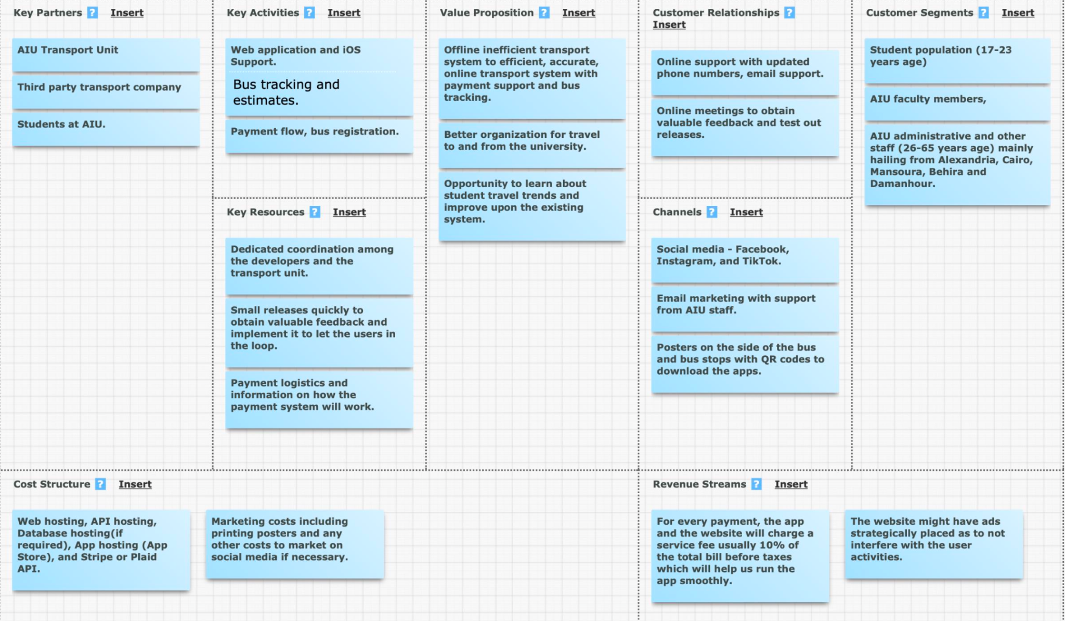

## Project Charter

● Vision  
 An efficient, easy to use, user-friendly online transit system used by the students, faculty, and administration at AIU as a part of their daily life. The system allows the users peace of mind when traveling to and from the university.

● Goals

○ A fully functional web and mobile application focused on excellent  
user experience and accurate information about the transit system.

○ Reliable and quick support and cancellation support (24 hours  
prior).

○ Allowing multiple buses to run according to the user data, since  
currently only one bus runs at specific times which wastes time of  
students and faculty members.

○ Provide stakeholders with valuable user data and financial  
information to understand user behaviors and provide better/profitable service in the future.

● Scope  
○ In-Scope

○ Payment system to book online and cancellation support.

○ Estimated arrival and departure time of different buses.

○ Timely updates about any unforeseen circumstances or bus route  
Changes.

○ Availability of seats and route information.  
○ Out-of-scope

Live tracking of the buses (Costly hardware has to be installed)

Offline support for the bus route information. (Automated messaging or calling)  
Android application (Not enough time

* Values

Embrace Change - Be willing to implement user feedback as quickly as possible and improve upon the system.  
Quick software releases and web hosting upkeep.  
Deep collaboration between users and stakeholders.

● Success Measures

* ○ 10 buses carrying 280 students, fully operating using the app with registration,payment, and tracking system.
* ○ 300 user hits on the website and 100 app downloads on iOS devices.
* ○ 4.5+ rating on App Store and good reviews to be published on the website.
* ○ Promotion in the AIU Voice Club, Facebook, Newsletter, and local radio.

● Working Agreements

* ○ Commitment to the values stated above.
* ○ Clear communication regarding availability and skill experiences to  
  delegate work properly.
* ○ Committing to internal deadlines and patience with colleagues.
* ○ Respecting personal and work boundaries due to the time  
  difference.

## Personas

## Story Tasks and Prioritization List

1. Show
   * The correct number of seats for the corresponding bus is given.
   * The number of seats is updated with every online ticket purchase
   * The bus seats are reset every day except for weekly and monthly tickets.
   * The bus information is correct for each driver and every bus.
   * Correct driver is rated depending on the ticket a user bought.
   * For low ratings the user needs to give a brief description of their  
     experience.
2. Estimated Bus Tracking System - 75
   * The bus stops for each bus are correct and updated regularly.
   * The bus tracking system stays within an error range of +-10 mins.
   * Bus tracking is updated every 15 minutes with a new position (if changed)  
     of the bus.
   * Any discrepancies or changes on the route are updated on the system  
     within 30 mins.
   * The bus route and stops on the map are correctly shown for each bus.
   * All the buses should be updated based on the day they are running and  
     any altered hours.
   * If a bus is delayed due to any reason, the bus routes and times should be  
     altered accordingly.
3. Login/Authentication - 3
   * Detect already existing email or new email and redirect to the appropriate page.
   * Detect aiu.edu email address and make sure only one student is registered with one email address.
   * Detects a strong password of 8 characters with Uppercase,lowercase, number, and symbol.
   * Use university id to make sure a student is registered and eligible for the services. (By uploading the university id and correctly detecting the student id number)
4. Bus Route Information - 5
   * Verify the bus route information with bus drivers to make sure the regions  
     are marked correctly on the map.
   * The information is updated on holidays and rush days.
5. Online Booking - 75
   * Verify the student is registered at the university.
   * Verify the correctness of the card details using Luhn’s Algorithm.
   * Make sure there are no time conflicts between different bus tickets.
   * Limit the bus ticket to two per student.
   * Correctly records the time at which the ticket was bought to allow  
     alterations 24 hours prior.

the number of seats in the bus and the ability to rate Driver - 25

f. Correctly update the seat lefts in the bus. 6. Updated Weather/Bus information - 20

* Make sure any changes in route or itinerary is updated within 30 minutes due to weather or unforeseen circumstances due to road closings or flat tires.
* Correctly updates the emergency dialog box on the website.

Tasks

1. Show
   * JavaScript based API. - 6 hours
   * Deployment on Heroku/Railway. - 1 hour
   * MongoDB database. - 1 hour
   * Authentication for different endpoints. - 4 hours
   * Jest/Postman for testing endpoints. - 5 hours
   * HTML/CSS to view the data in a user friendly way. - 1 hour
   * Ask the user for location timestamp so that we can estimate bus timings  
     more accurately. - 2 hours
2. Estimated Bus Tracking System - 75
   * User friendly map with all the bus stops and bus routes. - 7 hours
   * Updated location of the buses on the map every 15 minutes. - 1 hour
   * HTML/CSS/JavaScript website to portray the requested bus data. - 1 hour
   * User friendly drop down menu to select different buses to view their  
     Information. - 1 hour
   * Get location timestamps every 15 minutes to keep the bus location  
     updated. - 1 hour
3. Login/Authentication - 3
   * A user-friendly interface (HTML/CSS) for an easier process for  
     registration. - 1 hour
   * Doing authentication for users using Oauth 2.0. - 2 hours
   * Checking for password strength using HTML. - 1 hour

4. Bus Route Information - 5

* User friendly map with all the bus stops and bus routes. - 7 hours
* Updated location of the buses on the map every 15 minutes. - 1 hour
* Authentication for driver & bus data. - 2 hours

the number of seats in the bus and the ability to rate Driver - 25

5.Online Booking - 75

* Stripe or Plaid api integration with correct banking information. - 4 hours
* Integration of Luhn’s algorithm if required. - 1 hour
* Limiting the user to 2 bus tickets one to the university and one from the  
  university using previous tickets bought for the day. - 2 hour
* Saving history of the purchased tickets on the app and allowing the user  
  to rebook the previous ticket quickly. - 2 hours

6. Updated Weather/Bus information - 20

* Showing pop-up messages in case of a problem of who should be called. - 1  
  hour
* Showing pop-up messages in case of closed streets or streets could delay the  
  trip. - 1 hour

## Estimation

Weightage - 1,3,5,10,20,50,75,100

Youssef - Y  
Keshav - K  
Soliman - S

| **FEATURES** | **Round 1** | **Round 2** | **Round 3** |
| --- | --- | --- | --- |
| Estimated Tracking System | Y-75,K-50,S-75 | Y-75,K-75,S-75 |  |
| Login/Authentication | Y-1,K-20,S-20 | Y-1,K-3,S-3 | Y-3,K-3,S-3 |
| Online Booking and Cancellation | Y-75,K-100,S-50 | Y-75,K-75,S-75 |  |
| Updated Bus Information and Weather Updates | Y-20,K-50,S-20 | Y-20,K-20,S-20 |  |
| Number of seats in the bus | Y-50,K-20,S-20 | Y-20,K-20,S-20 |  |
| Bus routes | Y-5,K-50,S-1 | Y-5,K-5,S-5 |  |
| Rate driver | Y-1,K-1,S-5 | Y-1,K-1,S-1 |  |

Prioritization of the stories:-

1. **Estimated tracking system, Rate Driver - Noura, First Sprint**
2. Login/Authentication - Noura, Liad, Khairy
3. Bus Routes - Ziad
4. Number of seats - Ziad, Khairy
5. Online Booking - Khairy
6. Updated bus information - Ziad

## Burn-up Charts

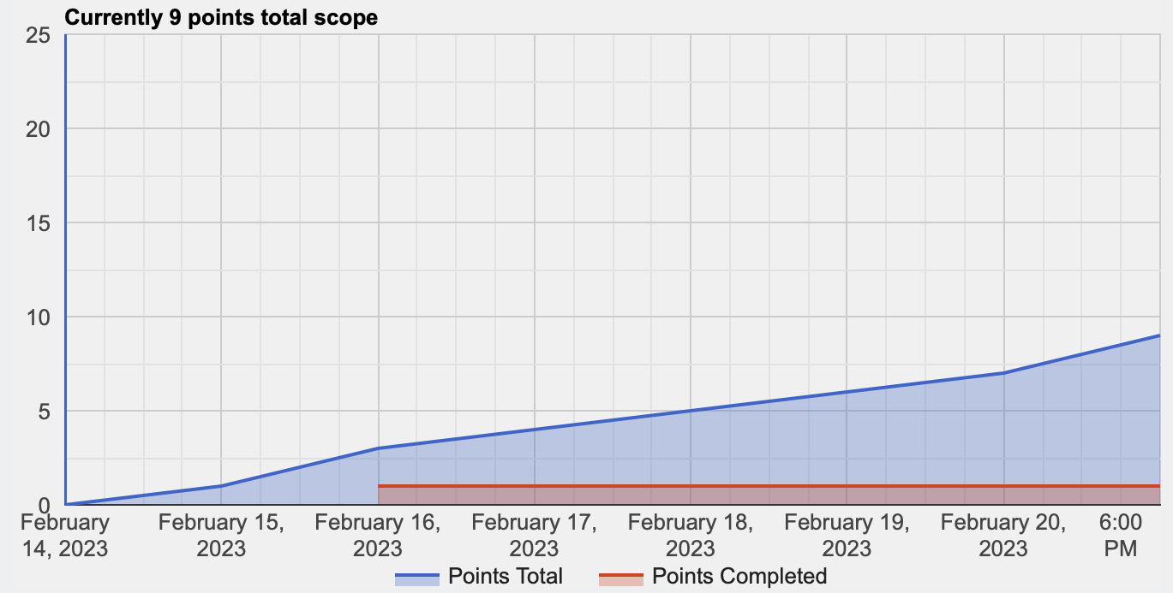

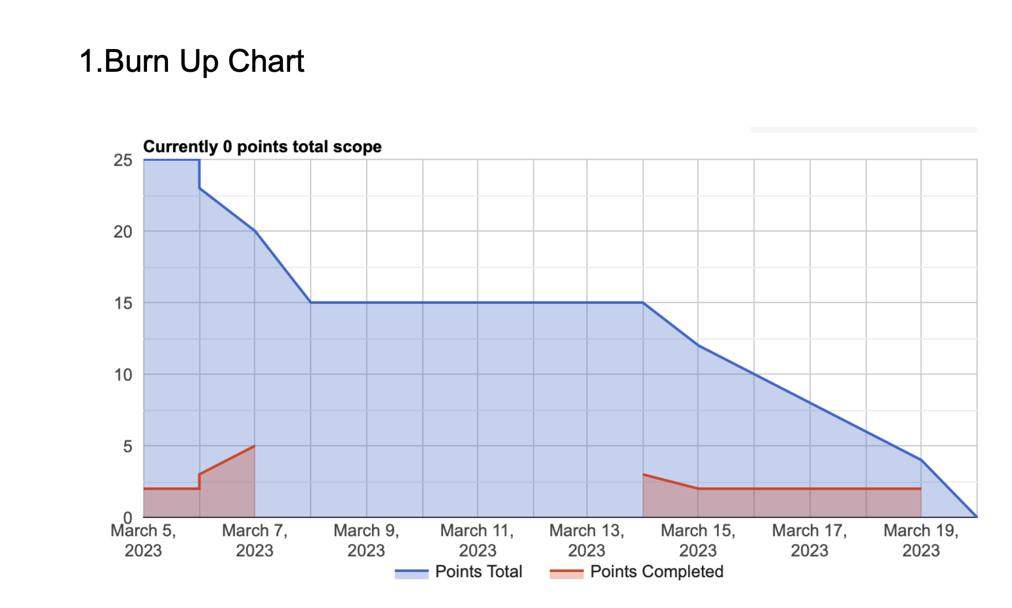

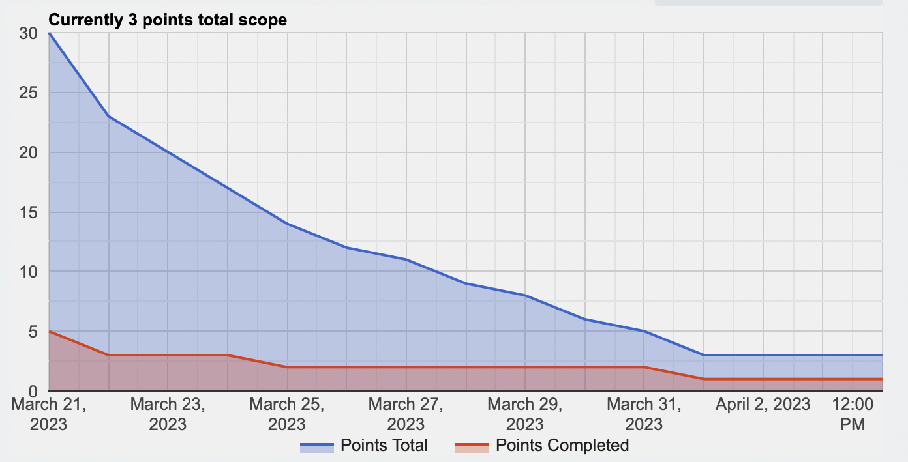

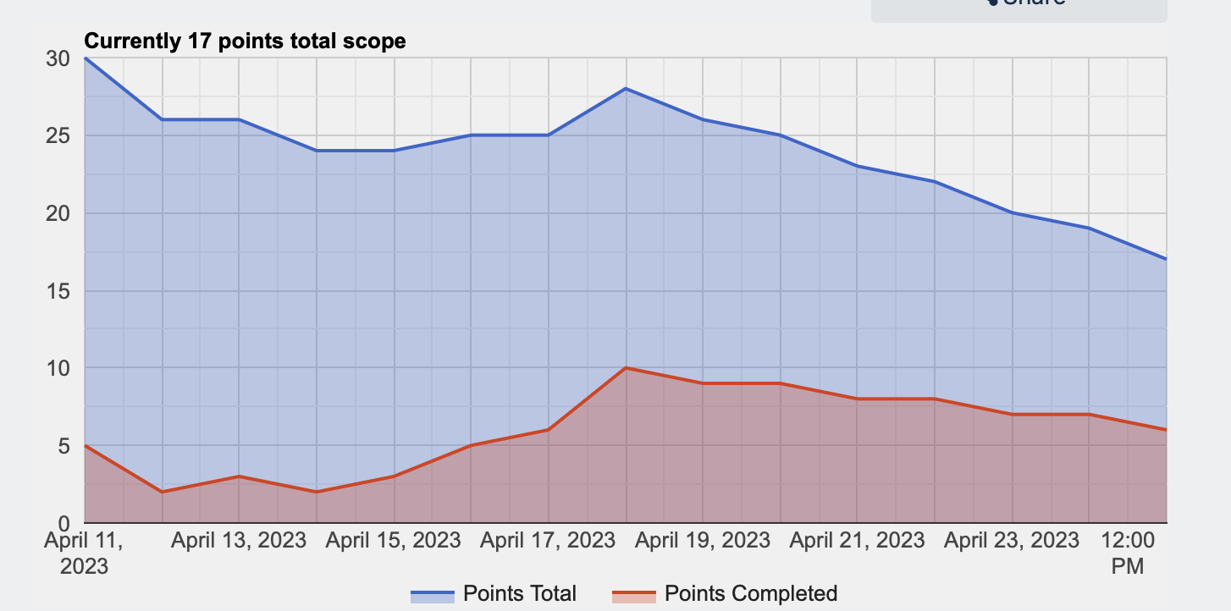

## Links

Github

<https://github.com/keshavbhateja/SobekNew>

Trello

<https://trello.com/b/pXTlCnae/sobek-transit>

Heroku

<https://sobektransit.herokuapp.com/>

Presentation Slides  
[Sobek Transit Demo](https://docs.google.com/presentation/d/1krjmARHCFcuUWmV9b9Dy7m_oA25Lhw-LUZGFCHvwXk4/edit?usp=sharing)

## Feedback

## Goals Comparison

Goals achieved

* Functional web-app focused on user-friendly UI and information about the transit system.
* Multiple bus route information stored and retrieved from the database.
* Collecting valuable user data about bus route history for stakeholders.

Goals not achieved

* Accurate information about the transit system and seat information.
* Presentable user data to stakeholders and bus drivers
* Bus booking system to notify drivers.
* Information for the number of buses is not enough to make a valuable improvement on the existing system.

## Success Measures Evaluation

* Instead of 10 buses we only have 5 operational route information.
* 36 user hits on the website excluding repeated visits.
* Promotion in the AIU voice club.
* App Features: Working user-friendly UI, Authentication, Booking system, Route information for 5 buses and their routes on google maps with feedback system.
* Measures not achieved: Intended user hits, bus information for 10 buses, booking system which updates drivers.

## Retrospection

Things which went well:-

* Clear idea of what the final product should look like.
* Honest evaluations of each other's abilities.
* Dividing tasks.
* Jumping in when someone needs help.
* Being able to maintain a healthy working environment and being patient with everyone.

Things which didn't go well:-

* Internal deadlines and what we need to achieve every week.
* Communication gaps and updating each other regularly.
* Maintaining Trello board and asking for help when needed.
* A regular meeting time due to changing commitments.

## Recommendations

* Set rigid internal deadlines and meet more often than you think.
* Be honest with your progress and ask for help whenever needed.
* Re-organize and reflect on success measures often